Computer Engineering Department

Course Name: CMPE281– Cloud Technologies

Student Name: Navit Gaur

Instructor: Jerry Gao, Ph.D., Professor

Lab Assignment #1: Playing with Amazon Elastic Compute Cloud (EC2)

Semester: Fall, 2015

Summary:

**(a)** Set up an AMAZON WEB SERVICE (AWS) user account;

**(b)** Create an EC2 instance;

**(c)** Launch and deploy the selected application (or an instance) onto my selected cloud environment. In my case I selected an EC2 instance to work on Windows environment and create a sample HTML programme in the instance. Then execute this program and verify the result.

Detailed Steps:

1. Set up a user account in AWS:

1.1. Create an AWS account through http://aws.amazon.com/ and enter login

credential information or login in by using existing Amazon account.

1.2. In my case I created a new account and signed up.

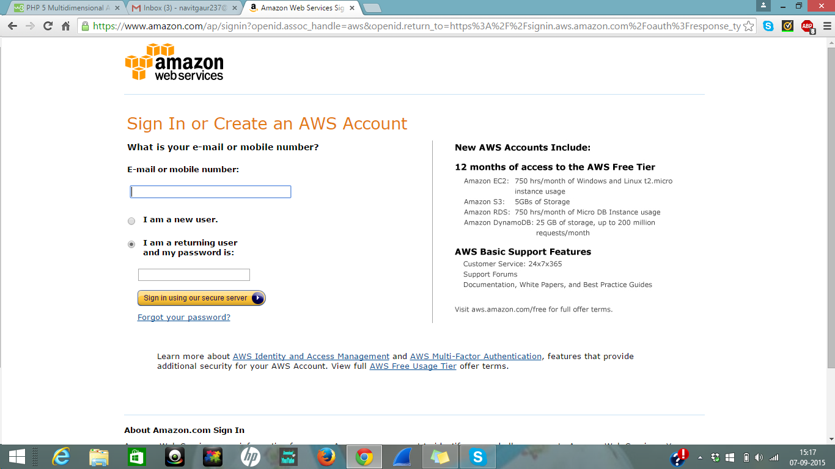

1.3 Enter your login credentials like name, email, password etc.

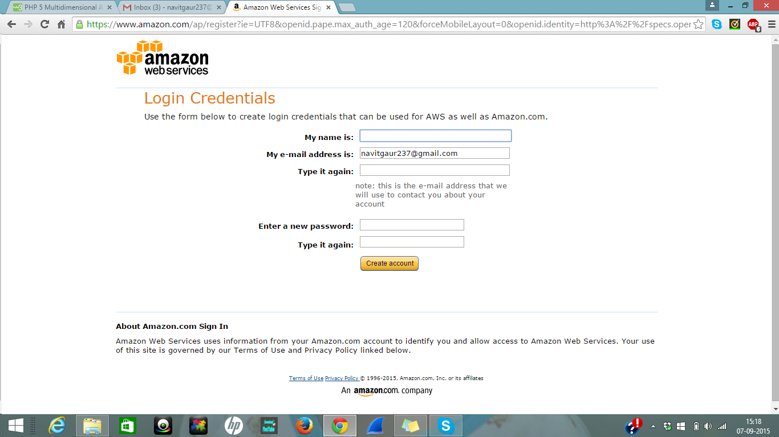

1.4. After this proceed further to enter your contact information.

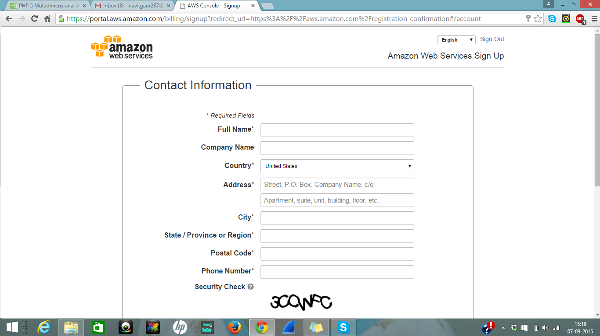

1.5. Then enter payment information.

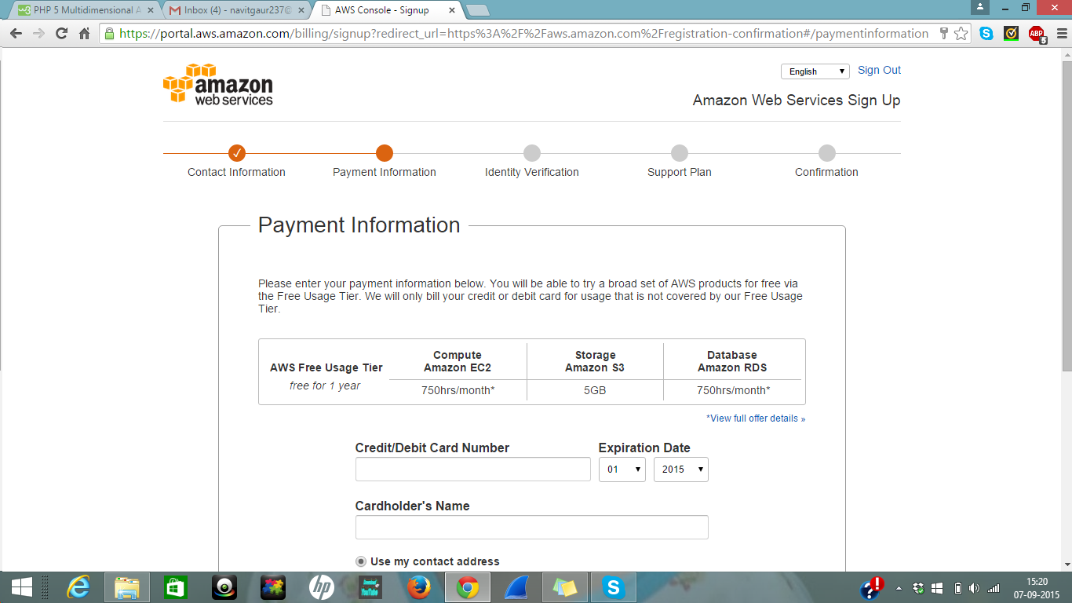

1.6. Verify the information through auto phone call.

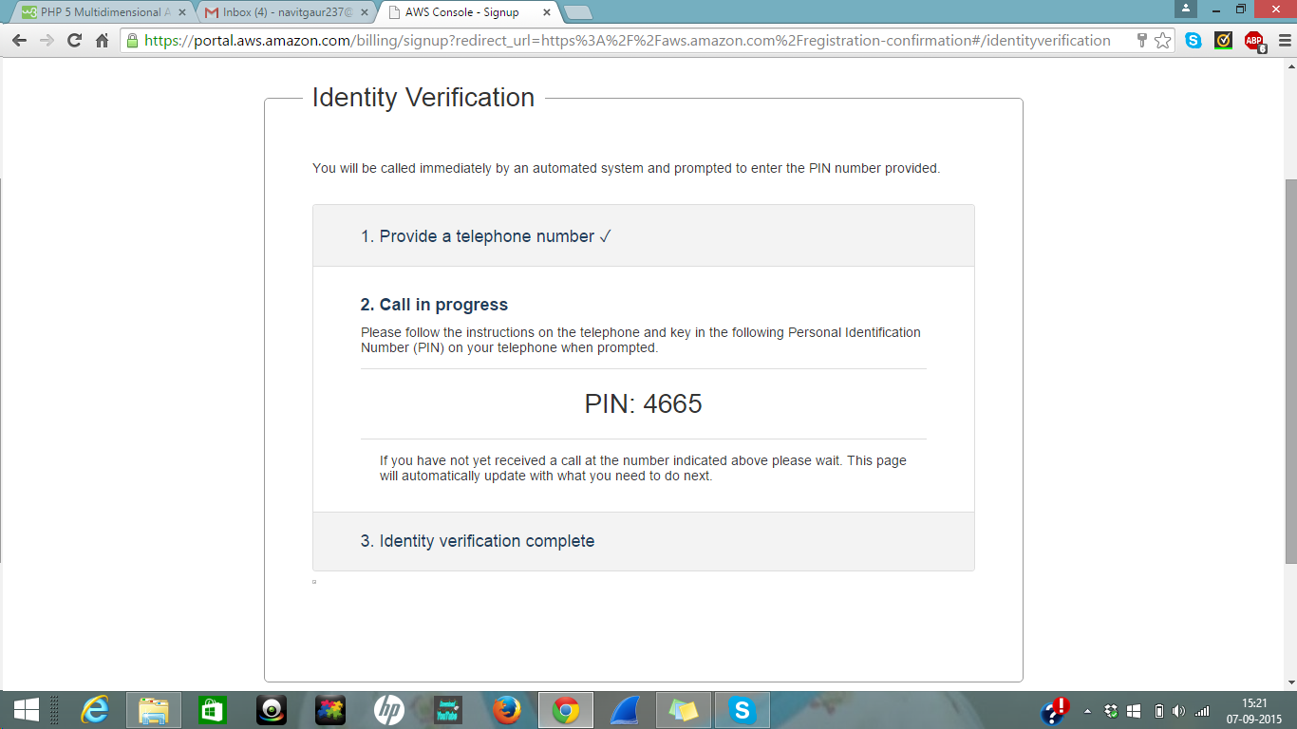

1.7. Then select the plan you want. In my case I selected the basic plan free of cost.

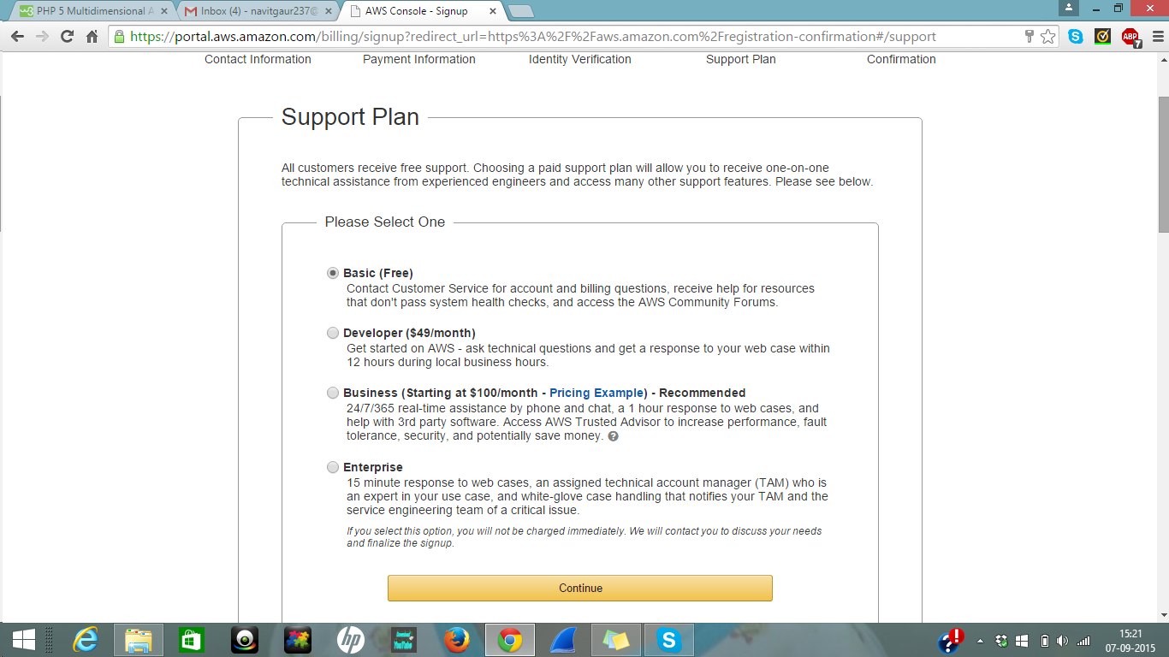

1.8. Amazon sent account information to your specified email after identify verification completed successfully.

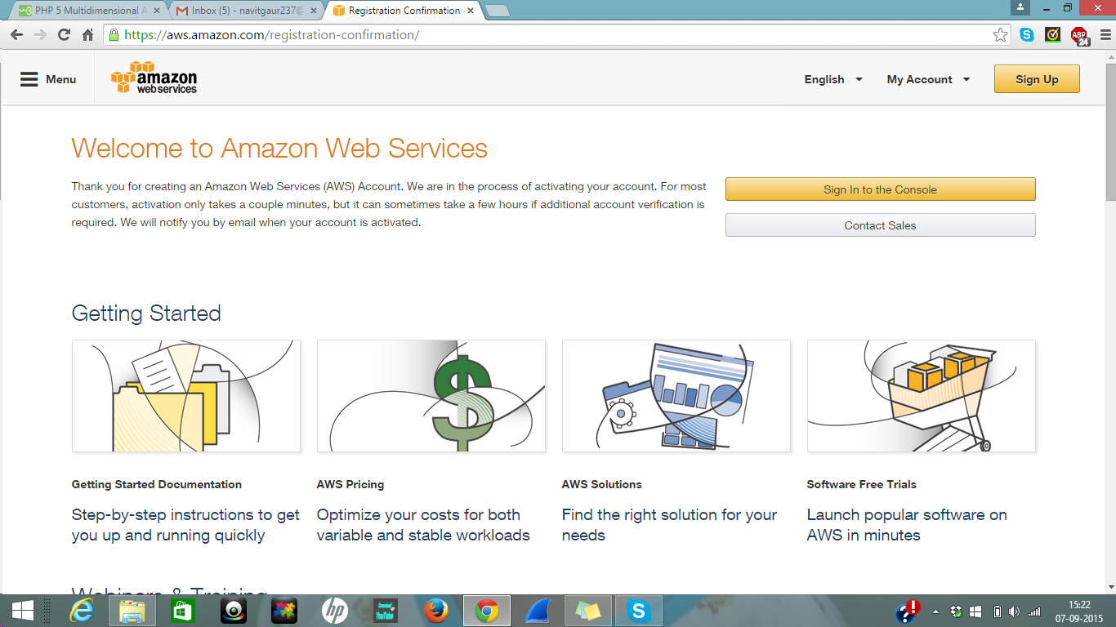

1.9. Log in your Amazon Web Services (AWS) account

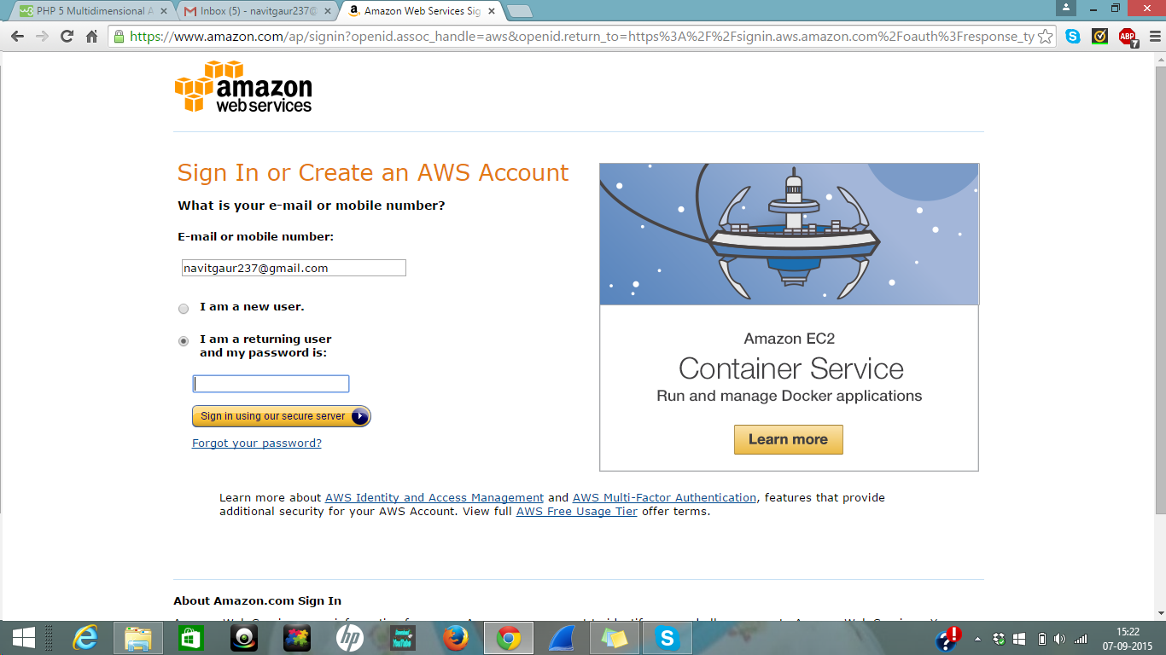

2. Create an EC2 instance:

2.1 Log in to the AWS Management Console http://aws.amazon.com/console/, then sign in by using your just created AWS account information. Next, click the “Amazon EC2” tab.

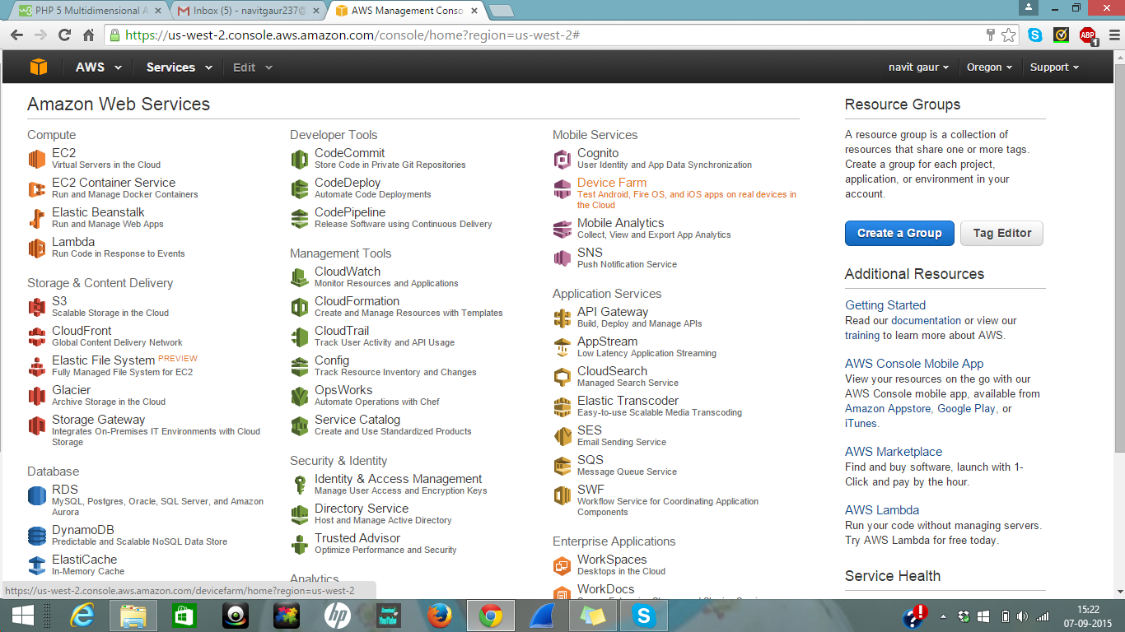

2.2 Click “Launch Instance”.

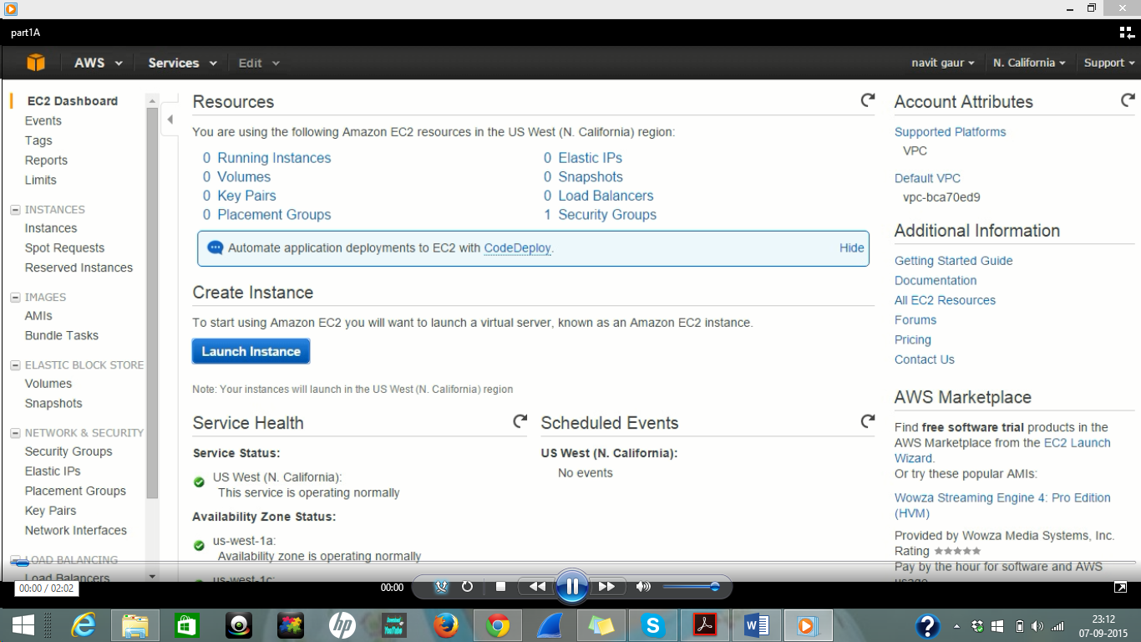

2.3 Create an instance based on your need. In this case, I created a free Windows Server 2012

R2 base environment instance. Just Select the Amazon Machine Image (AMI).

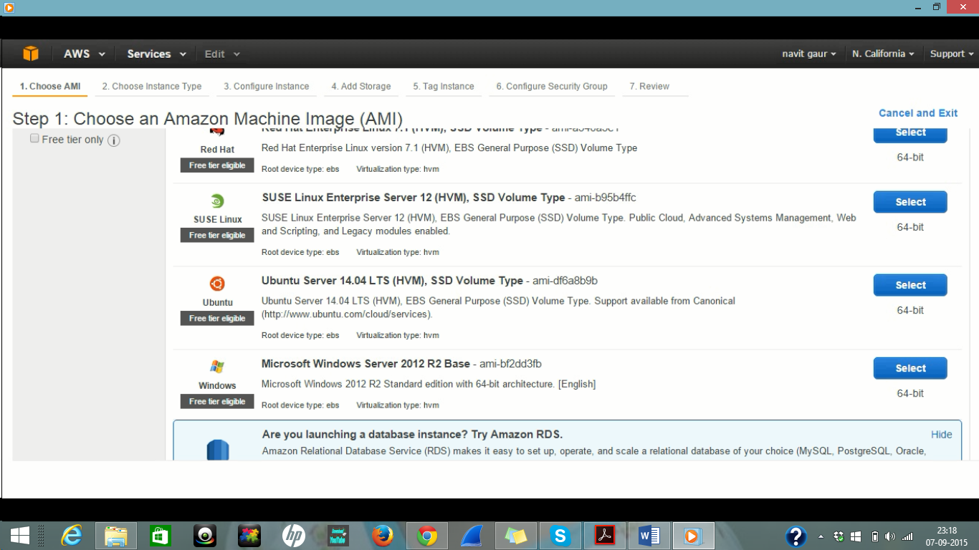

2.4. Select the instance type of your choice. In my case I selected the GENERAL PURPOSE.

T2 micro instance type which is for free and then click review and launch.

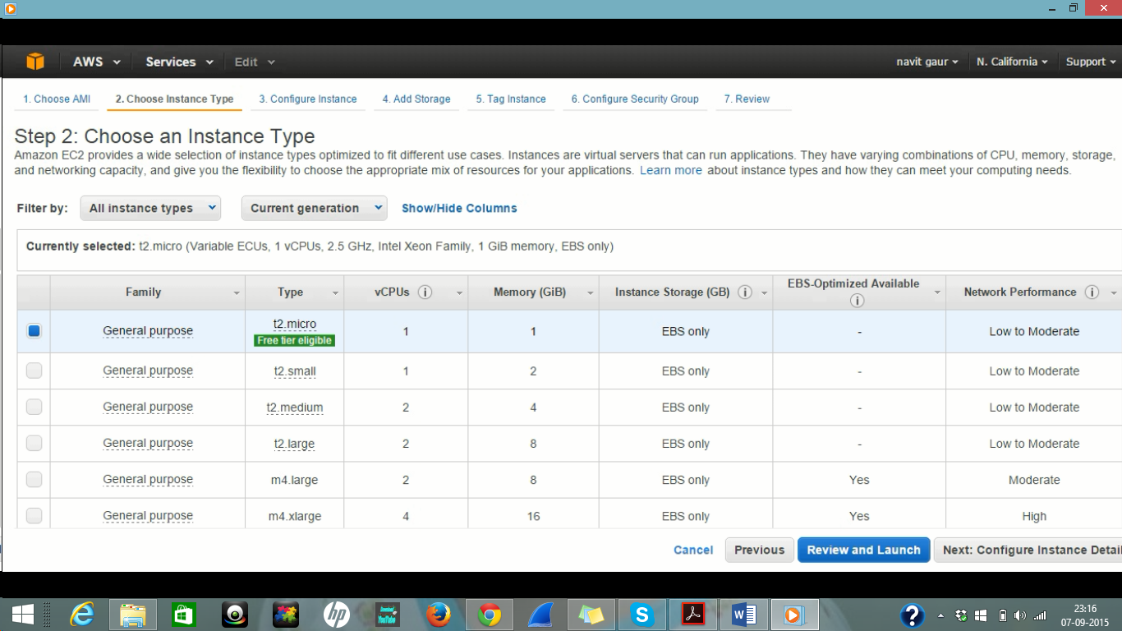

2.5. Review the Instance launch details once again and click Launch.

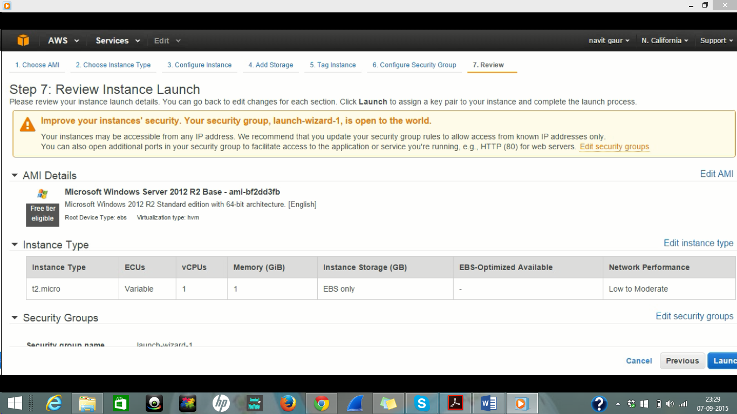

2.6. Now you will see a message to create a new key pair or use existing. Since we are using first time create a new public – private key pair and give it a name. After this click download key pair and once the key is downloaded click Launch Instance.

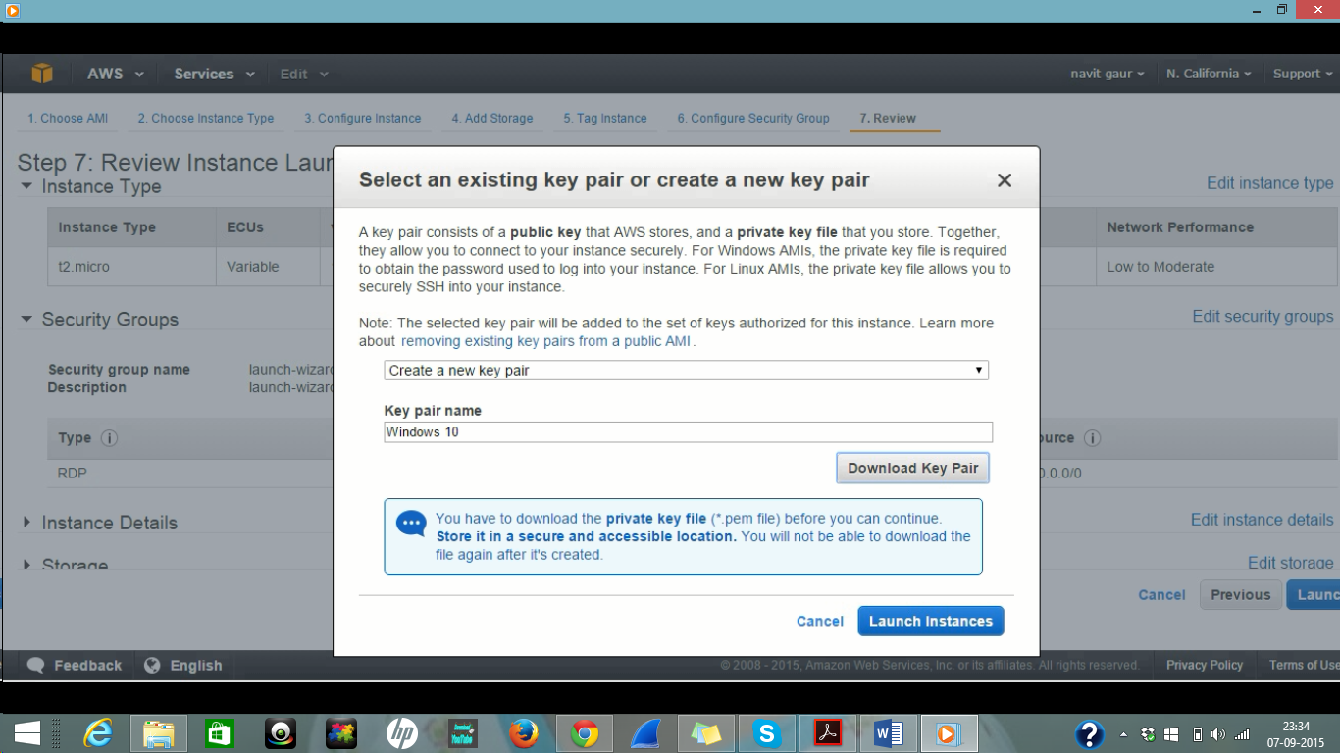

2.7. After this a screen appears which says Launching instance. If you see the following page, a new instance is launched successfully.

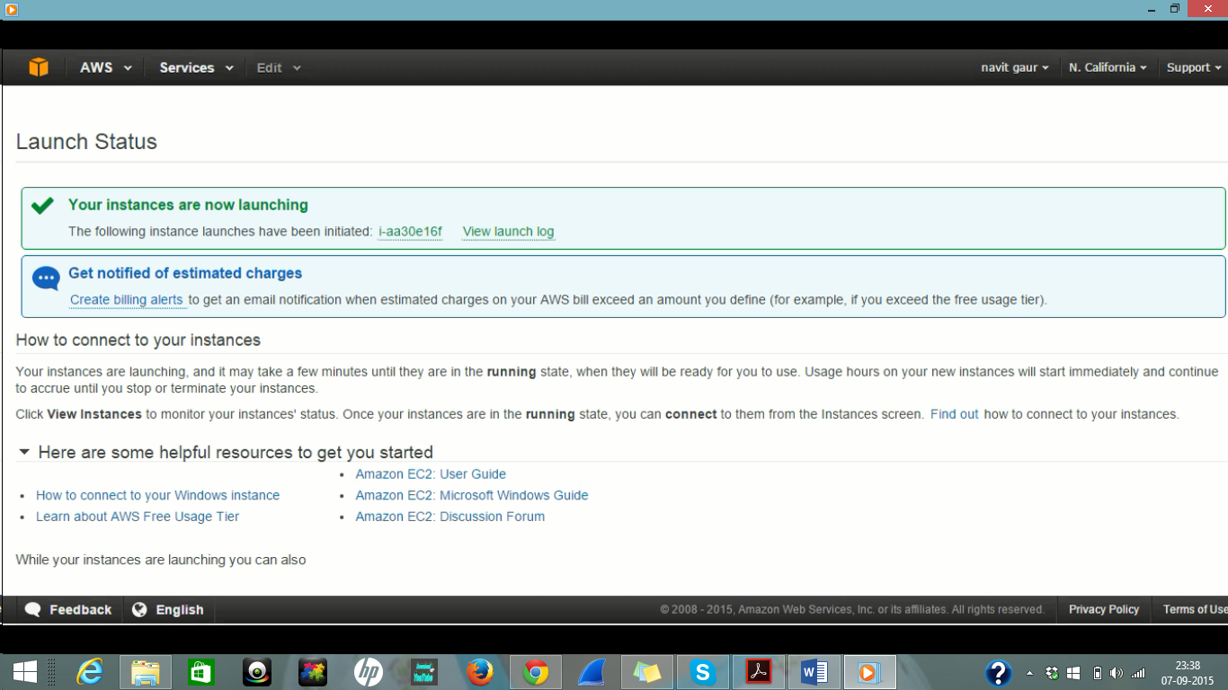

2.8. Now click on view instance to see your instance status. You can see your just created instance is in running status through the following web.

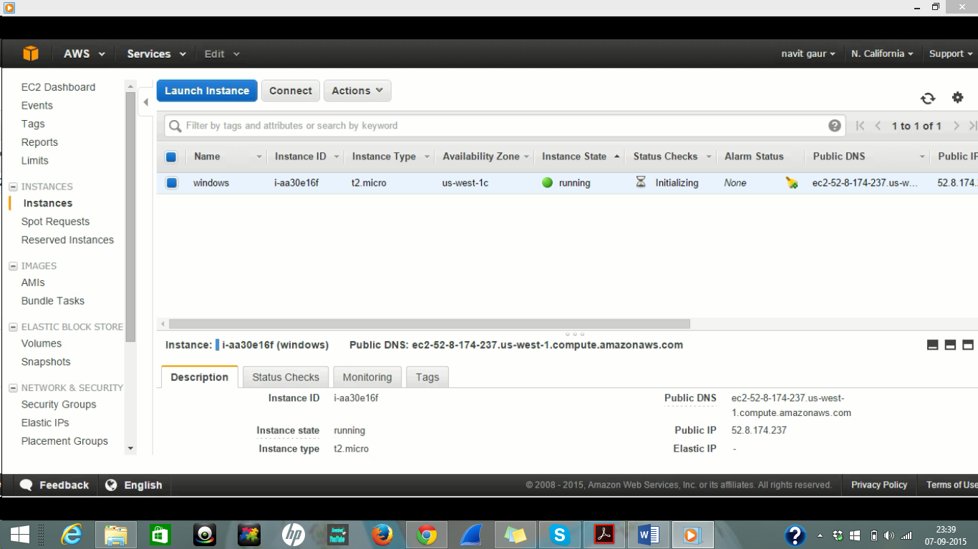

**3. Managing the EC2 instance and running a sample programme:**

3.1. Click on Connect button so that a dialog box appears.

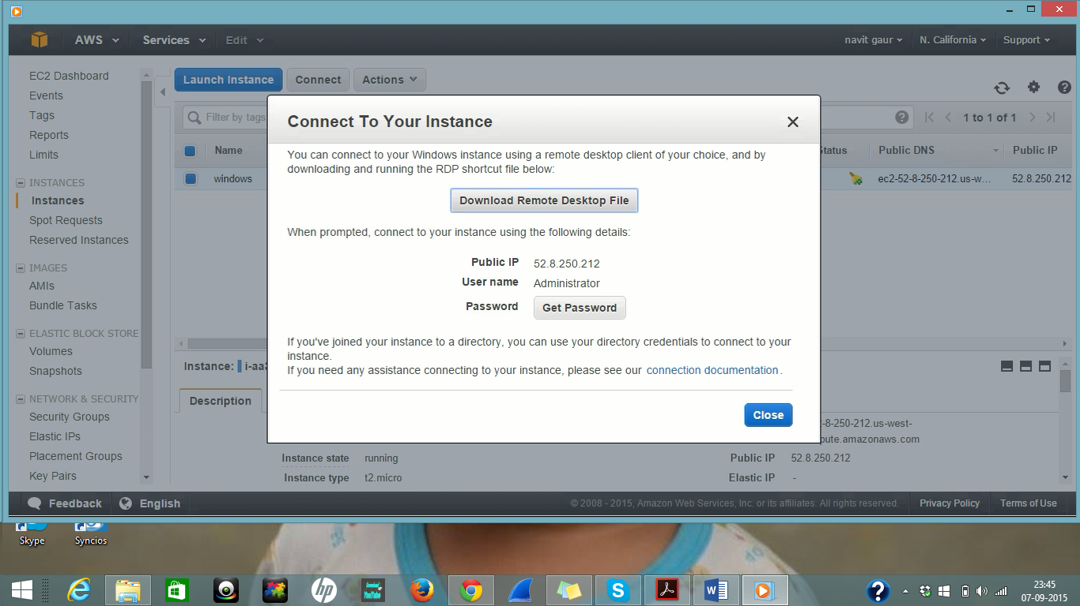

3.2. Now click on Download Remote Desktop File and then click on Get Password button.

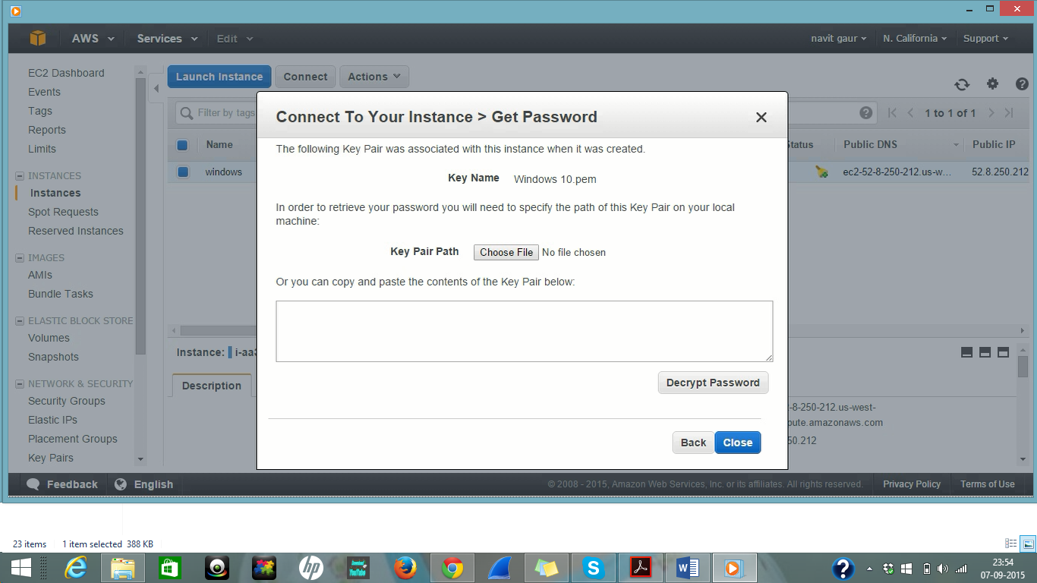

3.3 Key name will automatically be filled with the name we gave in Step 2.6. In my case it is Windows 10.pem file. Then browse the private key file which we downloaded in step 2.6 and click decrypt password.

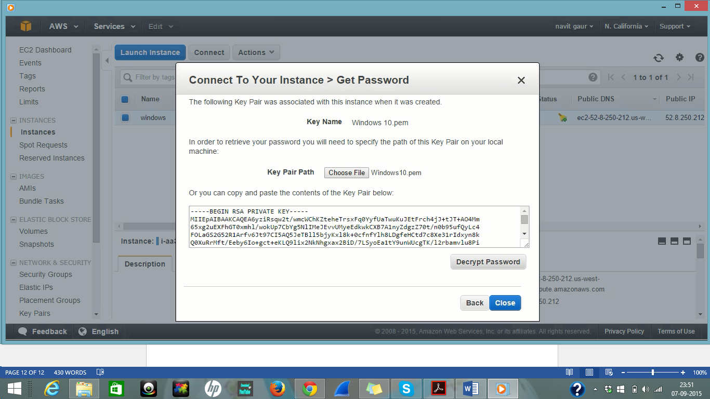

3.4 copy the password and click close.

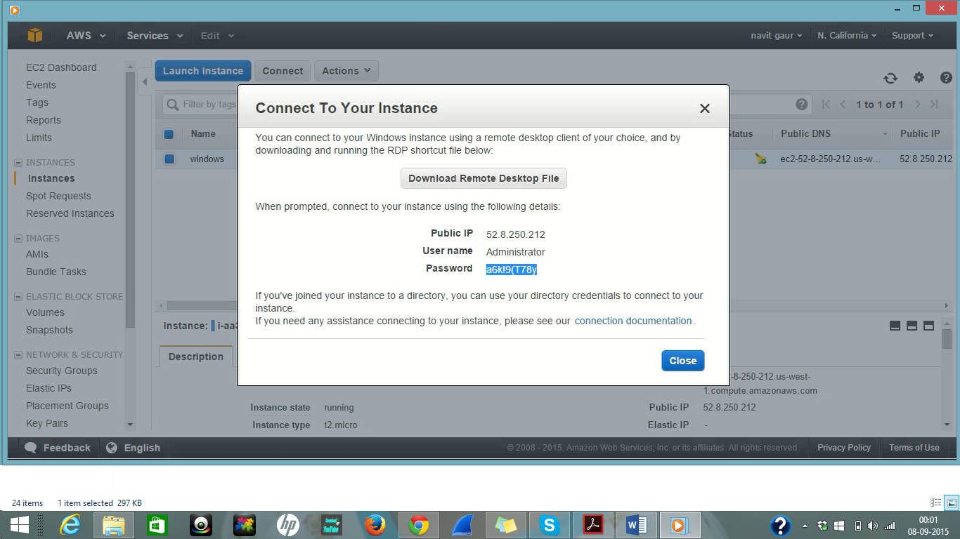

3.5 Now Run the Remote Desktop File which we downloaded in step 3.2 and click on Connect

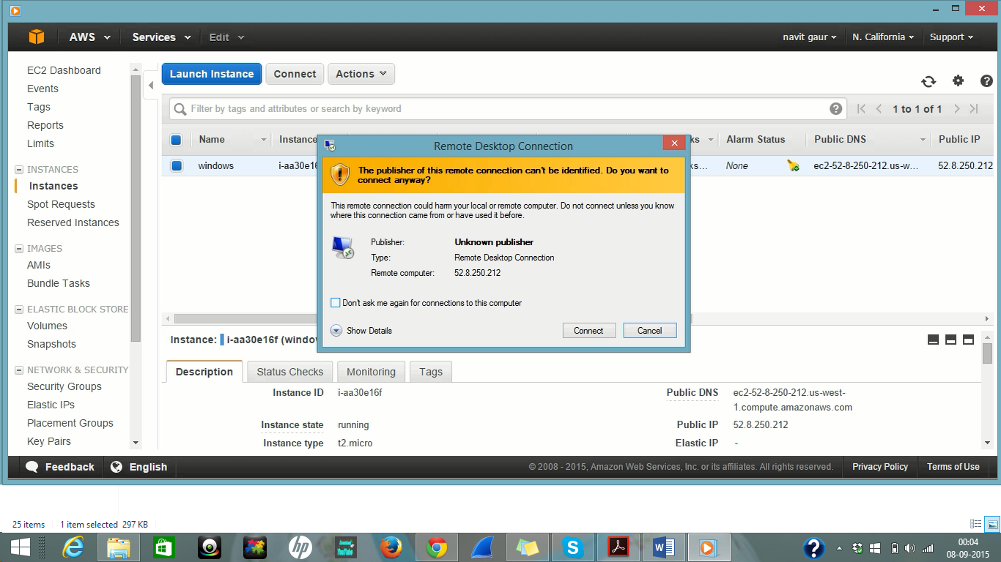

3.6 Enter the login credentials generated from step 3.4 and click OK

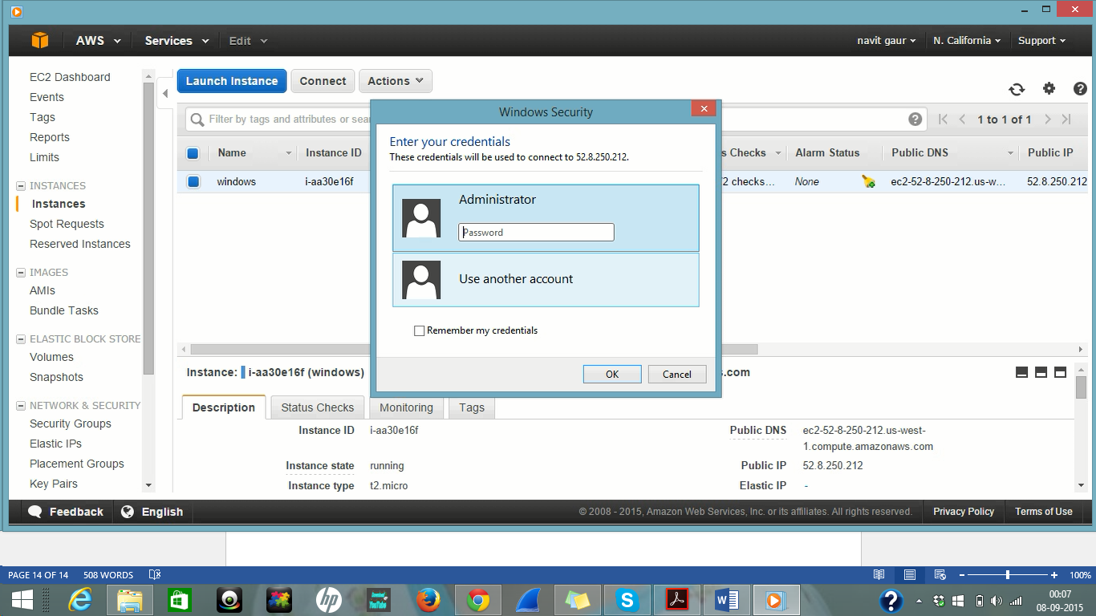

3.7 Accept the certificate and the AMI environment is launched. In my case it is Windows Server 2012.

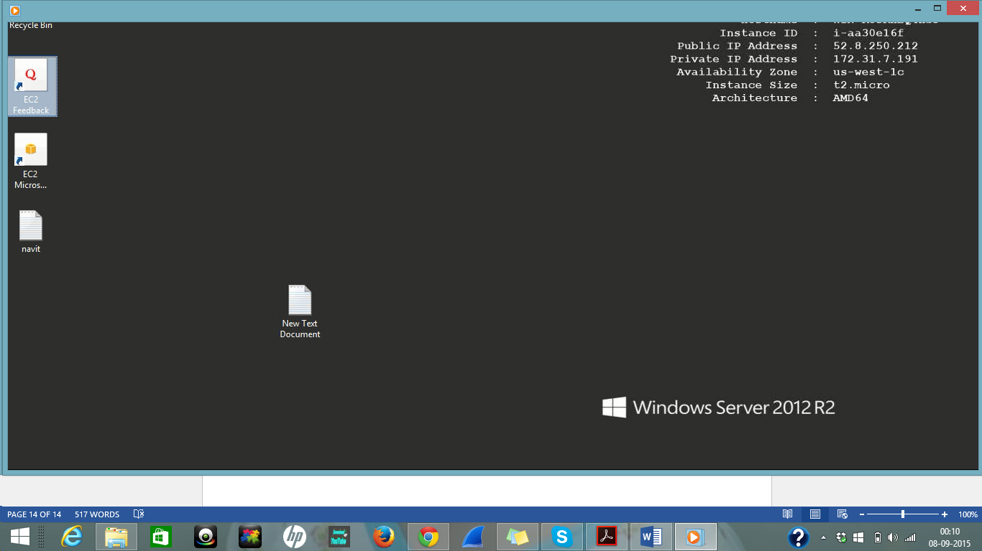

3.8 Create a random HTML programme and run the programme to check if it is properly working. In my case I created a simple HTML programme to give output HELLO PROFESSOR GAO.

